Android Developer Bootcamp
Signup Screen
Workshop #01

🎯 Purpose
This workshop helps you practice designing a simple user signup screen using XML layout only.
You will use basic UI components to create a clean form layout.

🧩 Problem
Design a simple signup screen UI in Android using XML.
The screen should contain the following elements:

🏷️ Title
- A TextView at the top
- Text should be: "Create Account"
- It should be centered and clearly visible

📞 Phone Number Field
- An EditText for entering phone number
- User should be able to type numbers
- Show hint text: "Enter Phone Number"
- Keyboard should show numeric input (number type)

🔒 Password Field
- An EditText for password input
- Hint text: "Enter Password"

🔘 Button
- A Button labeled: "Sign Up"
- It should be placed below the input fields

How to Solve
1. Checkout the workshop from Git Repo:
git clone -b <user-branch> <repo-URL>
2. Open the root folder inside Android Studio
3. To build the app click the run option

🎯 You Will Achieve
After completing this workshop, you will understand:
- How to design a simple signup screen using XML
- How to use TextView, EditText, and Button
- How to arrange UI elements in a vertical layout
- How to use hints and input types

📸 Screenshots
Before Implementation
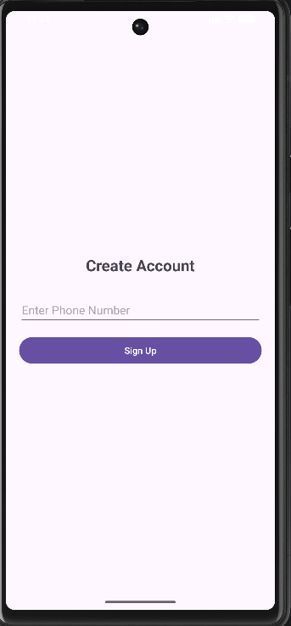

After Implementation

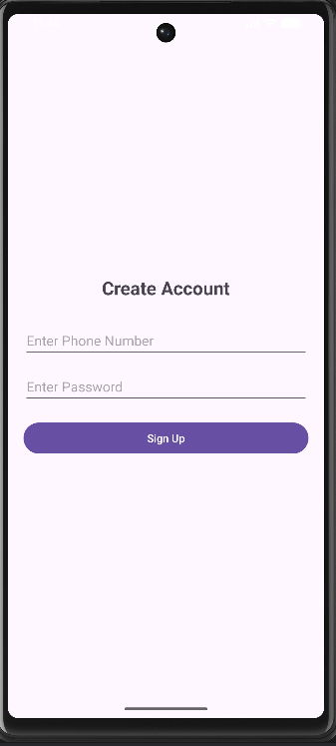

How to submit your workshop
Push your project back to the same git branch using command:
<command name>
🚀 Happy Coding!

